**Lab report no 4**



**Spring 2023**

# Web Engineering Lab

**Submitted By**

**Name Registration No**

# Muhammad Ali 19pwcse1801

Section: **A**

**Date**: 2,04,23

**Submitted to: Mam Madeha**

Department of Computer Systems Engineering

University of Engineering and Technology, Peshawar

**Task No 1: -**

**HMTL: -**

**Output: -**

**Task No 2: -**

**HMTL: -**

<!DOCTYPE html>

<html lang="en">

<head>

    <meta charset="UTF-8">

    <meta http-equiv="X-UA-Compatible" content="IE=edge">

    <meta name="viewport" content="width=device-width, initial-scale=1.0">

    <title>text changing with button</title>

</head>

<body>

<h2>White Color is who's favourite!!!!</h2>

    <p>

        White is a color often associated withi purity, innocence, and cleanliness It is the color of fresh snow, a blank canvas, and a pristine wedding dress. In some cultures, White is also associated with mourning and is.

        worn at funerals in design and fashion, White is often used to create a sense of simplicity, elegance, and modernity. White is a versatile color that can evoke a variety of emotions and meanings, depending on the context in which it is used</p>

    <p>color changing :<input type="text" id="input-colorname"> <button type="submit" id="color-change-button" >changed color</button>

</p>

<p style="color: brown;">Muhammad Ali</p>

<script src="https://ajax.googleapis.com/ajax/libs/jquery/3.6.1/jquery.min.js"></script>

<script src="task2.js" charset="UTF-8"></script>

</body>

</html>

**JavaScript’s: -**

//alert("ali");

$(document).ready(function() {

    $('#color-change-button').click(function() {

      var newColorword = $('#input-colorname').val();

      $('body').html(function(i, oldHtml) {

        return oldHtml.replace(/White/g, newColorword);

      });

    });

  });

**Output: -**

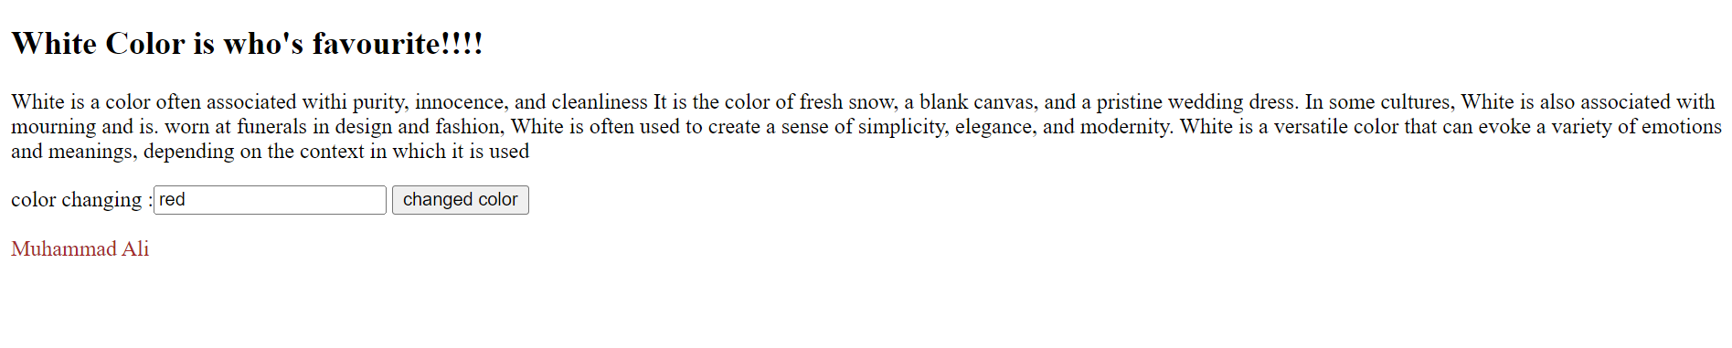

**Task No 3: -**

**HMTL: -**

**Output: -**

**Task No 4: -**

**HMTL and JavaScript’s: -**

    <!DOCTYPE html>

    <html>

    <head>

    <meta charset="utf-8">

    <title> Boxes with jQuery</title>

    <style>

    .rect {

    width: 100px;

    height: 100px;

    margin: 10px;

    border-radius: 0;

    border: 2px solid black;

    display: inline-block;

    }

    .rounded {

    border-radius: 50%;

    }

    </style>

    <script src="https://code.jquery.com/jquery-3.6.0.min.js"></script>

    <script>

        $(document).ready(function() {

        // Toggle colors button

            $("#colorButton").click(function() {

            $(".rect").each(function() {

            var currentColor = $(this).css("background-color");

            if (currentColor === "rgb(0, 0, 255)") {

            $(this).css("background-color", "yellow");

            }

            else {

            $(this).css("background-color", "blue");

            }

            });

            });

        $("#borderButton").click(function() {

          $(".rect").toggleClass("rounded");

        });

        $("#add-box-Button").click(function() {

          var newRectangle = $("<div class='rect'></div>");

          $("#rect3").after(newRectangle);

        });

        });

    </script>

    </head>

    <body>

        <div id="rect1" class="rect"></div>

        <div id="rect2" class="rect"></div>

        <div id="rect3" class="rect"></div>

    <br>

    <br>

    <h1>Toggles</h1>

        <button id="colorButton">Toggle Colors</button>

        <button id="borderButton">Toggle rounded Borders</button>

        <button id="add-box-Button">Add boxes</button>

        <p style="color:brown;">Muhammad Ali</p>

    </body>

    </html>

**Output: -**



